# User Guidelines

## API Documentation

### Server API endpoints

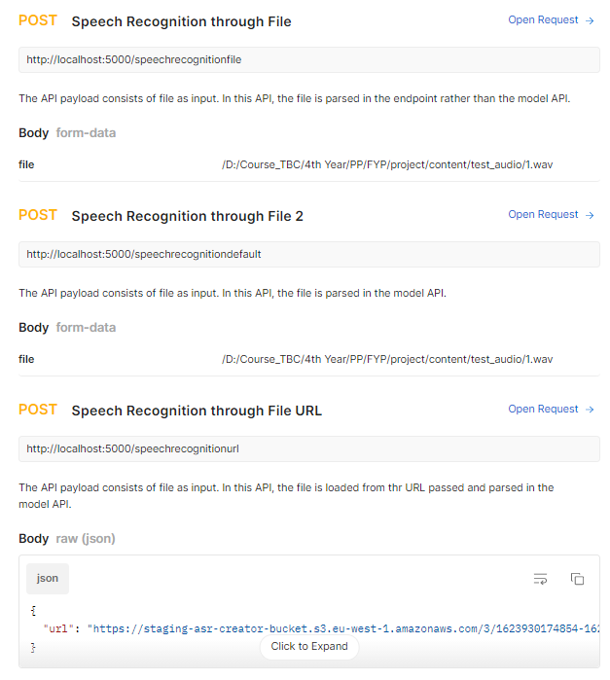

You can access the Postman API documentation at the link: [**https://documenter.getpostman.com/view/9905304/Tzm5GGHa**](https://documenter.getpostman.com/view/9905304/Tzm5GGHa)

## API access

You can run the API server from the command-line/ terminal using the command:

**python api.py**

After the server is live, you can directly access the GUI interface for using the engine in the URL:

[**http://127.0.0.1:5000/**](http://127.0.0.1:5000/)

or

<http://localhost:5000/>

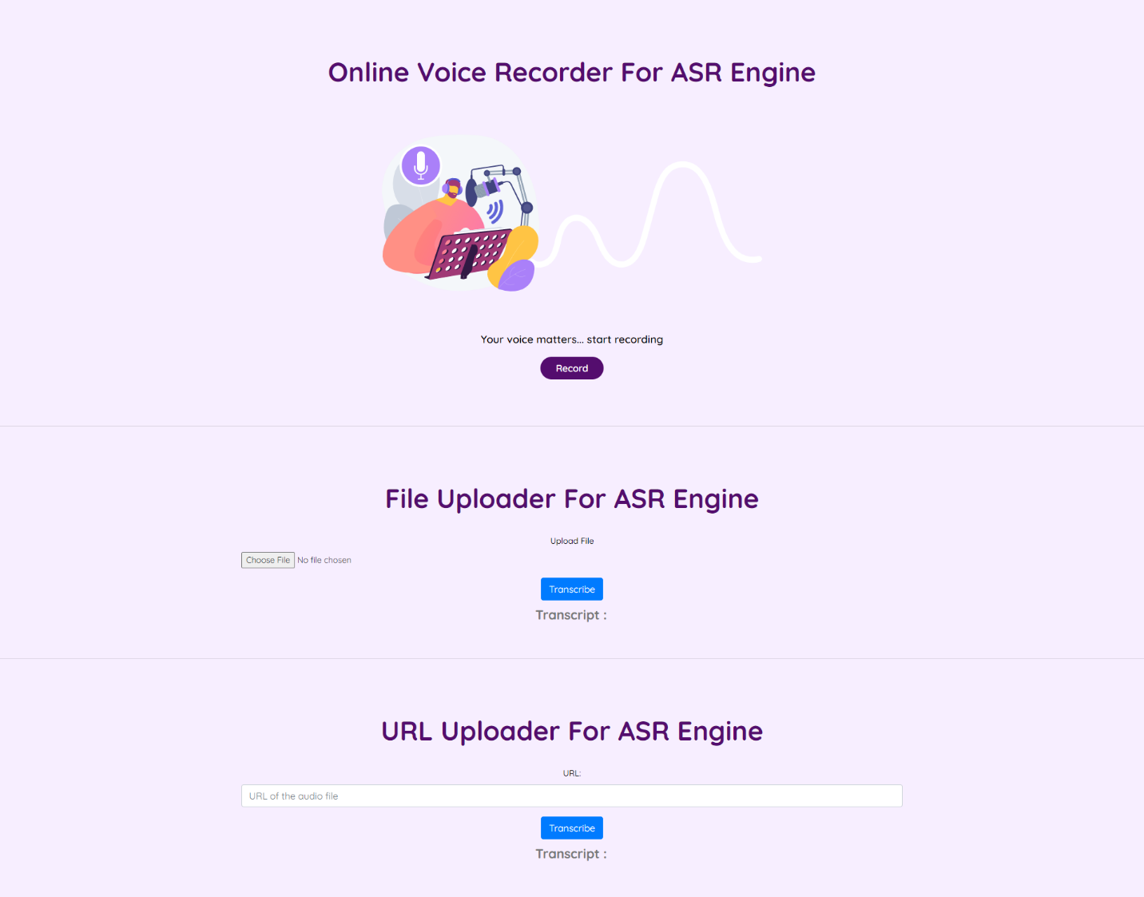

The ASR engine can be accessed through 3 different ways from the GUI, directly recording from the website, uploading a file for the ASR engine to parse or through URL where the required audio file is hosted.

Other POST routes can be accessed as documented above.